Assessment Schedule – 2014

Physics: Demonstrate understanding of aspects of wave behaviour (90938)

Evidence Statement
Question | Achievement | Merit | Excellence
ONE  (a)(i) &  (ii) | ONE correct description given in part (i) or part (ii).  Eg:  - A wave is a disturbance (that travels from one location to another).  - Waves transmit energy. | Waves transmit energy without carrying / transmitting matter. / Moving matter the entire distance
(b) | (i)  The correct directions are given. ←→ | (i)  The correct direction are given.  ←→
 | OR  (ii)  The correct wavelength is calculated. There are 3 wavelengths in 2.7 m.  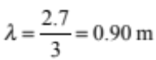  (m not required) | AND  (ii)  The correct wavelength is calculated. There are 3 wavelengths in 2.7 m.  (m not required)
(c) | Speed of the wave in water is calculated correctly.  Ie:  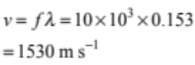  OR  Calculated distance halved. | Speed of the wave in water is calculated correctly BUT Distance between the cliff and the transmitter is incorrectly calculated as 826 m (but not halved to get 413 m).  OR  Speed of the wave is incorrectly calculated using f with wrong/no multiplier of Hz to calculate the distance between the cliff and the transmitter is as, eg 0.413 m, 4.13 m, etc.  OR  d = 413 (with no unit or incorrect unit) | Distance between the cliff and the transmitter is correctly calculated.  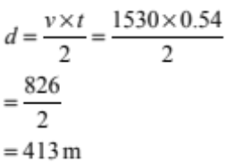  (correct unit required)

(d) | (i)  At least two complete waves drawn with decreasing amplitude (irrespective of wavelength). | (i)  At least two complete waves with same wavelength AND decreasing amplitude. | (i)  Exactly two complete waves with same wavelength AND decreasing amplitude.  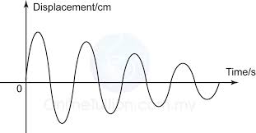
 | OR  (ii)  Wave loses energy. | OR  (ii)  Wave loses energy due to friction so amplitude is reduced.  OR  Energy is spread out over larger area so amplitude is reduced. | AND  (ii)  The wave loses energy due to friction/energy is spread out over a larger area which reduces the intensity of the wave so the amplitude becomes smaller.

N0 | N1 | N2 | A3 | A4 | M5 | M6 | E7 | E8
No response or no relevant evidence | 1a | 2a | 3a | 4a | 2m | 3m | 1e | 2e

Question | Achievement | Merit | Excellence
TWO  (a) | Diagram shows diffraction of sound wave – with diffraction towards Shelley ONLY. | 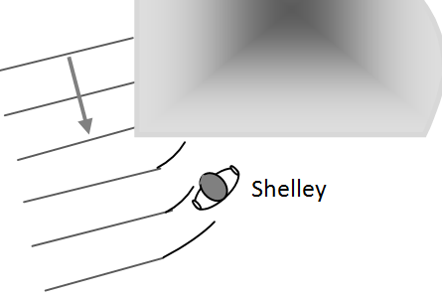  Diagram shows diffraction of sound wave – with diffraction towards Shelley ONLY  clearly showing no change in wavelength.
(b) | Identifies wavelength as a key factor, eg lower wavelength diffract more than shorter wavelength.  OR  Low frequency waves have a longer wavelength. | Low frequency waves have a longer wavelength.  AND  Diffraction is more pronounced with longer wavelengths (higher frequencies) than a with shorter wavelengths (higher frequencies). | Low frequency waves have a longer wavelength .  AND  Diffraction is more pronounced with longer wavelengths (higher frequencies) than a with shorter wavelengths (higher frequencies).  SO  The longer wavelengths bend enough / sufficiently / more waves reach Shelley (but the short wavelengths do not).
(c) | High frequency reaches Shelley as well as low frequencies.  OR  The sound heard from reflection is louder / clearer.  OR  Sounds of all frequencies will get to Shelley by reflection. | The sound heard from reflection is louder/clearer because she now hears both the reflected AND diffracted waves.  OR  Sounds of all frequencies will get to Shelley by reflection so she hears the high frequency sound louder/clearer than before.

(d) | The amplitude of the waves stays (about) the same / both decrease / one decreases and one stays the same | The amplitude of the waves stays (about) the same/both decrease / one decreases and one stays the same | The amplitude of the waves stays (about) the same / both decrease / one decreases and one stays the same
 | OR  The change in direction of a reflected wave is abrupt / complete / bounces (back) and the a diffracted wave spreads out / bends. | AND  The change in direction of a reflected wave is abrupt / complete / bounces (back) and the a diffracted wave spreads out / bends. | AND  The change in direction of a reflected wave is abrupt / complete / bounces (back) and the a diffracted wave spreads out/bends
AND
One of the 4 ideas is explained, eg:
- The change in direction of a reflected wave is abrupt / complete as the law of reflection is
i = r.

N0 | N1 | N2 | A3 | A4 | M5 | M6 | E7 | E8
No response or no relevant evidence | 1a | 2a | 3a | 4a | 2m | 3m | 1e | 2e

Question | Achievement | Merit | Excellence
THREE  (a) | Either of:  - Refraction  - Dispersion
(b) | (i)  Top ray labelled as the red and 4th ray labelled as green. | (i)  Top ray labelled as the red and 4th ray labelled as green.
 | OR  (ii)  Light with different wavelengths / frequencies disperses / refracts by different amounts / different angles / travels at different speeds in glass. | AND  (ii)  Different coloured light waves have different wavelengths / frequencies.  AND  Different wavelengths / frequencies refract by different amounts /travel at different speed in glass.
(c) | (i)  Total internal reflection. | (i)  Total internal reflection. | (i)  Total internal reflection.
 | OR  ONE of:  - The ionised layer is optically less dense than the air above the Earth’s surface.  - The angle of incidence of B is greater than the critical angle (for this boundary).  - The angle of incidence of A must be less than the critical angle. | AND  TWO of:  - The ionised layer is optically less dense than the air above the Earth’s surface.  - The angle of incidence of B is greater than the critical angle (for this boundary).  - The angle of incidence of A must be less than the critical angle. | AND  THREE of:  - The ionised layer is optically less dense than the air above the Earth’s surface.  - The angle of incidence of B is greater than the critical angle (for this boundary).  - The angle of incidence of A must be less than the critical angle.

(d) | ONE idea:  - Correct refracted ray OR apparent position is drawn on diagram (tracing back of ray does not need to be shown).  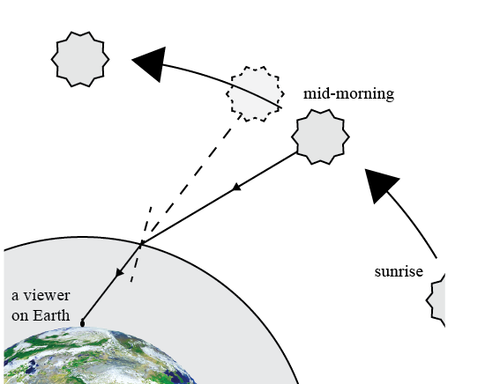 | TWO of three ideas:  - Correct refracted ray AND apparent position is drawn on diagram(tracing back of ray does not need to be shown). | ALL ideas correct:  - Correct refracted ray AND apparent position is drawn on diagram(tracing back of ray does need to be shown).
 | - The Sun appears to be in a different position than where it really is in the morning.  - The Sun appears to be in the same position as it really is at mid-day. | - As the Sun rises it gets closer to its true position.  - The Sun appears to be in the same position as it really is at mid-day. | - In the morning so the Sun is seen furtherest from its true position in the sky.  - As the Sun rises it gets closer to its true position.  - At mid-day the angle of incidence is zero / light travels along the normal / there is no refraction so the Sun appears in its true position.

N0 | N1 | N2 | A3 | A4 | M5 | M6 | E7 | E8
No response or no relevant evidence | 1a | 2a | 3a | 4a | 2m | 3m | 1e | 2e

Cut Scores
 | Not Achieved | Achievement | Achievement with Merit | Achievement with Excellence
Score range | 0 – 6 | 7 – 13 | 14 – 19 | 20 – 24

